Walkthrough: Creating your first WCF RIA Services Application
Contents
1 Installation 2
2 Creating a new WCF RIA Services application 2
2.1 Setting up the application 4
3 Adding Business Logic to a .NET RIA Services application 6
3.1 Add a Data Source 7
3.2 Add a Domain Service Object and Query for Data 10
3.2.1 Add a Custom Query 15
3.2.2 Add a Domain Data Source 17
3.2.3 Add Sorting/Filtering/Paging to the DataSource 19
4 Master Detail 22
4.1 Adding a DataForm 22
5 Updating the Database 24
5.1 Updating a record 24
5.2 Adding Custom Methods to a Domain Service 25
6 Validation 26
6.1 Basic Validation 26
6.2 Custom Validation 28
6.3 Add a new record 30
7 Authentication 36
7.1 Authentication 36
8 Completed Projects 39

Installation

Note: This topic is pre-release documentation and is subject to change in future releases.
The information contained in this document represents the current view of Microsoft Corporation on the issues discussed as of the date of publication. Because Microsoft must respond to changing market conditions, this document should not be interpreted to be a commitment on the part of Microsoft, and Microsoft cannot guarantee the accuracy of any information presented. This document is for informational purposes only. MICROSOFT MAKES NO WARRANTIES, EXPRESS OR IMPLIED, IN THIS DOCUMENT.
- Manually uninstall the following via Add/Remove programs in Control Panel:
  - Microsoft Silverlight (any version prior to Silverlight 3 RTW)
  - Microsoft Silverlight SDK
  - Microsoft Silverlight Tools for Visual Studio 2008
- Install Visual Studio 2010 RC.
- Install the following:
  - Silverlight 4 RC
  - Silverlight 4 RC SDK
- Install WCF RIA Services RC.

Creating a new WCF RIA Services application

- Start Visual Studio
- On the File menu, click New→ Project.
The New Project dialog is displayed.
- In the Project types pane, expand Visual Basic or C#, then select Silverlight.
- In the My Templates pane, select Silverlight Business Application.
- Change the project name to ‘HRApp’. Click OK.
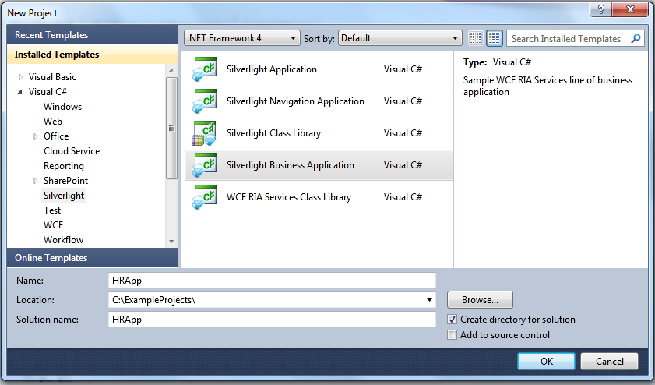

There are a couple of things to notice once the project is created:
  - The solution created for you consists of two projects: a Silverlight client project called HRApp and an ASP.NET Web Application server project called HRApp.Web.
  - The default application created for you has navigation, login/logout, new user registration enabled by default. Run the project and experiment with the default, out of the box application. When running the application for the first time, allow Visual Studio to Modify Web.config file to enable debugging.

NOTE – The default User Registration implementation requires SQL Server Express be installed on the machine.
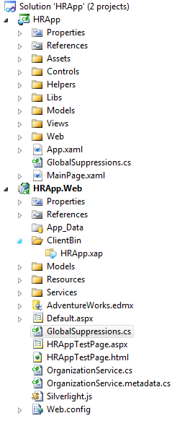

Setting up the application
- In the client project, open MainPage.xaml.
- Notice that the default XAML code (shown below) gets the application name from a resource.
<!-- XAML -->

<TextBlock x:Name="ApplicationNameTextBlock"
Style="{StaticResource ApplicationNameStyle}"
Text="{Binding ApplicationStrings.ApplicationName, Source={StaticResource ResourceWrapper}}"/>

- In the client project, open the Assets folder, and in that folder open the Resources folder.
- Open the ApplicationStrings.resx file, and change the ApplicationName resource to “HR Application”.
- Save and close the ApplicationStrings.resx file.
- In Solution Explorer, right click the HRApp project, select Add, and then select New Item. The Add New Item dialog box is displayed.
- In the Categories pane, select Silverlight and in Templates pane, select Silverlight Page. Name the new item ‘EmployeeList.xaml’ and click Add.
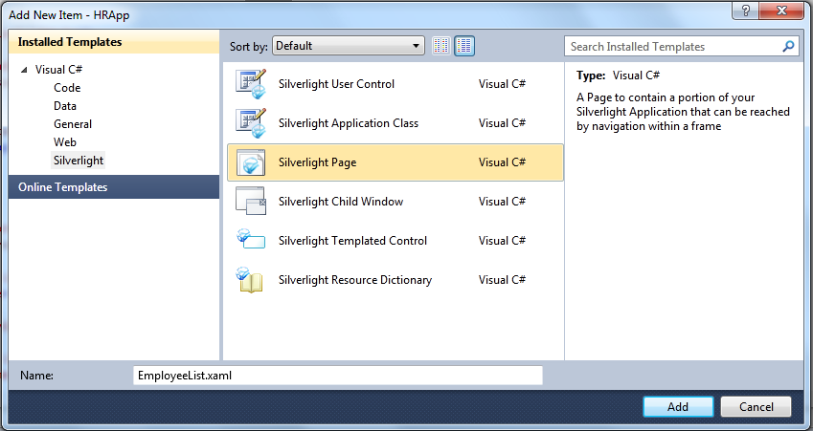

- Open EmployeeList.xaml and add the following XAML code between the <Grid> tags
<!-- XAML -->

<ScrollViewer BorderThickness="0" VerticalScrollBarVisibility="Auto" Padding="12,0,12,0" Margin="-12">
<StackPanel Margin="0,12,0,12" Orientation="Vertical" >
<TextBlock Text="Employee List" Style="{StaticResource HeaderTextStyle}"/>

</StackPanel>
</ScrollViewer>

- Save the EmployeeList.xaml file.
- In Solution Explorer, click EmployeeList.xaml and drag it to the Views folder.
- If you are using Visual Basic, add the following Imports statement to EmployeeList.xaml.vb.
Imports System.Windows.Controls
- Open MainPage.xaml and add a new link button to top of the page by adding the XAML code between the two existing link buttons.
<!-- XAML -->

<HyperlinkButton x:Name="Link3" Style="{StaticResource LinkStyle}" NavigateUri="/EmployeeList" TargetName="ContentFrame" Content="Employee List"/>

<Rectangle x:Name="Divider2" Style="{StaticResource DividerStyle}"/>

- Run the application and you will notice a new link button (‘Employee List’) has been added.

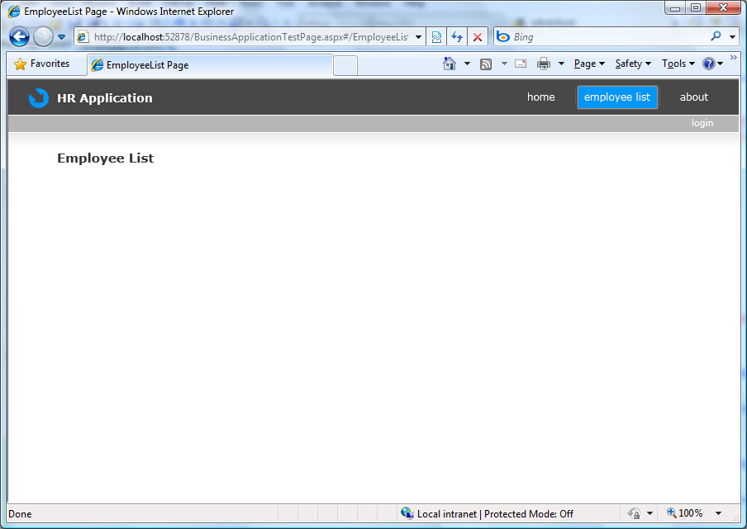

Adding Business Logic to a .NET RIA Services application
If you have the AdventureWorks database already installed feel free to use it; otherwise you can install one from CodePlex: http://msftdbprodsamples.codeplex.com/releases/view/4004

Add a Data Source
- In Solution Explorer, right-click the HRApp.Web project, select Add, and then select New Item. The Add New Item dialog box is displayed.
- In the Categories pane, select Data, and in the Templates pane, select ADO.NET Entity Data Model. Name the data model ‘AdventureWorks.edmx’ and click Add.

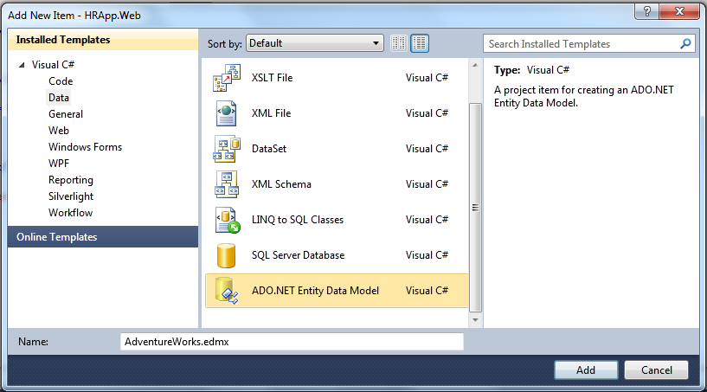
- In the Entity Data Model Wizard, choose to generate the Model from an existing database and click Next.

- Select the connection to the AdventureWorks database and then set the name of the entity connection settings to AdventureWorks_DataEntities.

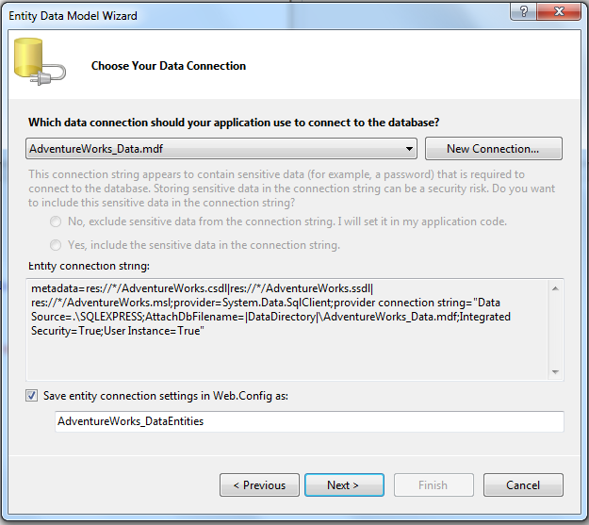

- Select Next.

- Expand the Tables node and choose the Employee table to be used by the Entity Data model. Set the model namespace to ‘AdventureWorks_DataModel’.

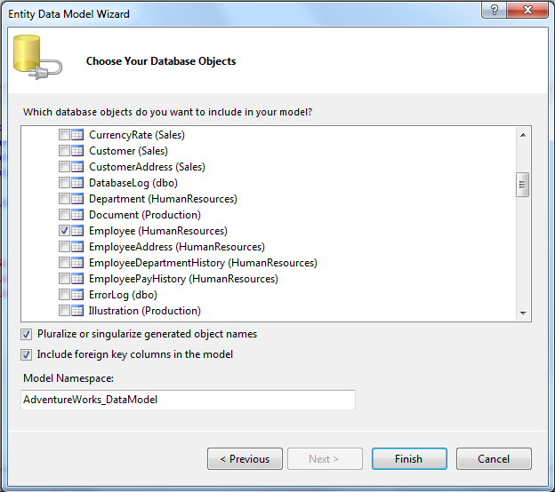

- Click Finish. The entity data model appears in the designer.

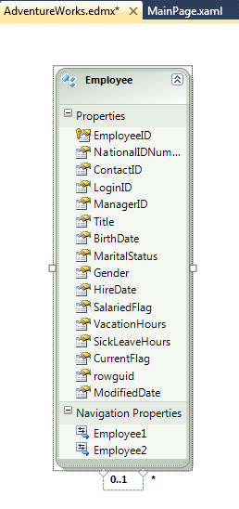
- On the Build menu, select Build Solution.

Add a Domain Service Object and Query for Data
- In Solution Explorer, right-click the HRApp.Web project, select Add, and then select New Item. The Add New Item dialog box is displayed.

- In the Categories pane, select Web, and in the Templates pane, select Domain Service Class. Name the new item ‘OrganizationService’.

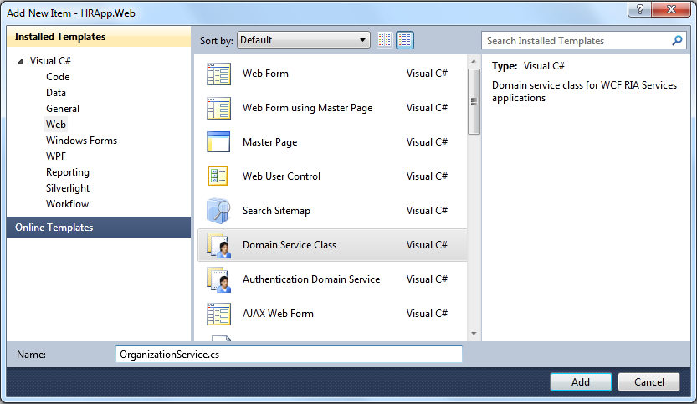
- Click Add
- In the Add New Domain Service Class dialog, select Employee from the Entities list, select Enable editing, and select Generate associated classes for metadata. Also, ensure that the Enable client access checkbox is checked.
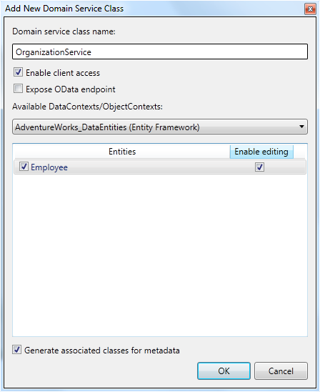

- Click OK.
- In the OrganizationService.cs/vb file, you will see that a query method and the Create/Update/Delete (CUD) data methods have been added. The CUD data methods were added because Enable editing was selected.
- Customize the select function by updating the GetEmployees() method to return the data sorted by EmployeeID.
Replace this generated code:
// C#

public IQueryable<Employee> GetEmployees()
{
return this.ObjectContext.Employees;
}

'VB

Public Function GetEmployees() As IQueryable(Of Employee)
Return Me.ObjectContext.Employees
End Function

With the following code:
// C#

public IQueryable<Employee> GetEmployees()
{
return this.ObjectContext.Employees.OrderBy(e => e.EmployeeID);
}

'VB

Public Function GetEmployees() As IQueryable(Of Employee)
Return Me.ObjectContext.Employees.OrderBy(Function(e) e.EmployeeID)
End Function

- On the Build menu, select Build Solution.
Building the solution generates the Domain Context and entities in the client project.
- In the client project, open EmployeeList.xaml.
- Open the Toolbox. The Toolbox is available from the View menu.
- Drag a DataGrid from the toolbox onto the XAML view for EmployeeList.xaml. Add the DataGrid inside of the StackPanel, just after the TextBlock.
Dragging a DataGrid into the XAML editor adds a reference to the System.Windows.Controls.Data assembly and maps the System.Windows.Controls namespace to a prefix. The prefix can be any value. In this walkthrough, the examples are shown with the prefix set to data.
<!-- XAML -->

<data:DataGrid ></data:DataGrid>
The prefix is set in the Page element.
xmlns:data="clr-namespace:System.Windows.Controls;assembly=System.Windows.Controls.Data"

- Name the DataGrid ‘dataGrid1’ , make it read-only, and set its minimum height by adding the following XAML..

<!-- XAML -->

<data:DataGrid Name="dataGrid1" MinHeight="100" IsReadOnly="True"></data:DataGrid>

- Save EmployeeList.xaml and build the solution.
- Open EmployeeList.xaml.cs/vb.
- Add the following using/Imports statements:

// C#
using HRApp.Web;
using System.ServiceModel.DomainServices.Client;

'VB
Imports System.ServiceModel.DomainServices.Client

- In the code generated for the client project, the OrganizationContext is generated based on OrganizationService. Instantiate the OrganizationContext class and load employee data by adding the following code (in bold) to EmployeeList.xaml.cs/vb:
// C#

namespace HRApp
{
public partial class EmployeeList : Page
{
OrganizationContext _OrganizationContext = new OrganizationContext();
public EmployeeList()
{
InitializeComponent();
this.dataGrid1.ItemsSource = _OrganizationContext.Employees;
_OrganizationContext.Load(_OrganizationContext.GetEmployeesQuery());

}

// Occurs when the user navigates to this page.
protected override void OnNavigatedTo(NavigationEventArgs e)
{
}

}
}

'VB
Imports System.Windows.Controls
Imports System.ServiceModel.DomainServices.Client

Partial Public Class EmployeeList
Inherits Page

Dim _OrganizationContext As New OrganizationContext
Public Sub New()
InitializeComponent()
Me.dataGrid1.ItemsSource = _OrganizationContext.Employees
_OrganizationContext.Load(_OrganizationContext.GetEmployeesQuery())
End Sub

'Occurs when the user navigates to this page.
Protected Overrides Sub OnNavigatedTo(ByVal e As System.Windows.Navigation.NavigationEventArgs)

End Sub
End Class
- Run the application. Click the Employee List link when the application is loaded to see the DataGrid.
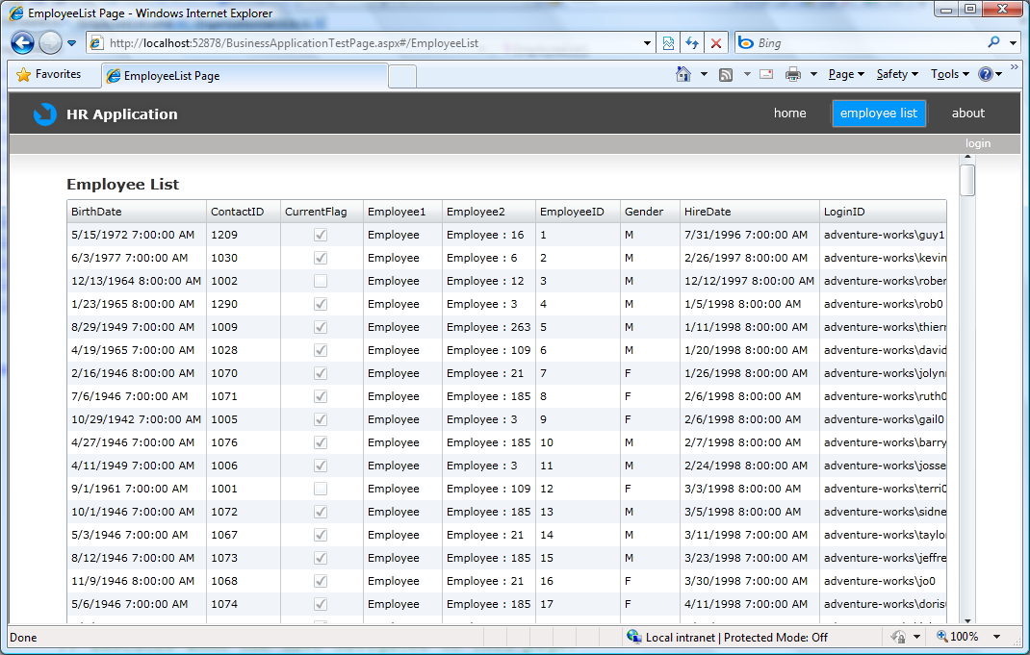

Add a Custom Query
- In the HRApp.Web project, open OrganizationService.cs/vb.
- Add a new method called GetSalariedEmployees by adding the following code to the body of the class.
// C#

public IQueryable<Employee> GetSalariedEmployees()
{
return this.ObjectContext.Employees.Where(e => e.SalariedFlag == true).OrderBy(e => e.EmployeeID);
}

'VB
Public Function GetSalariedEmployees() As IQueryable(Of Employee)
Return Me.ObjectContext.Employees.Where(Function(e) e.SalariedFlag = True).OrderBy(Function(e) e.EmployeeID)
End Function

- On the Build menu, select Build Solution.
- In the client project, open EmployeeList.xaml.cs/vb. A new query function is available in IntelliSense called OrganizationContext.GetSalariedEmployeesQuery.
- In the constructor, replace the call to GetEmployeesQuery() with a call to GetSalariedEmployeesQuery() .

// C#
_OrganizationContext.Load(_OrganizationContext.GetSalariedEmployeesQuery());

'VB
_OrganizationContext.Load(_OrganizationContext.GetSalariedEmployeesQuery())

- Run the application and click the Employee List link. Notice that employees 1, 2, and 4 no longer appear in the list because they are not salaried.
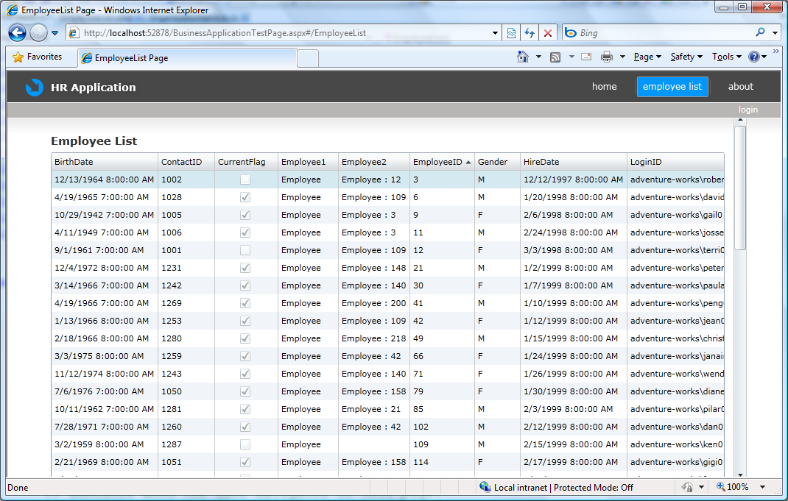

Add a Domain Data Source
- In the client project, open EmployeeList.xaml.
- Drag the DomainDataSource from the toolbox onto EmployeeList.xaml, just before the DataGrid.
- Change the namespace prefix for System.Windows.Controls from my to riaControls.
xmlns:riaControls="clr-namespace:System.Windows.Controls;assembly=System.Windows.Controls.DomainServices"

- For C# solutions, add the following namespace declaration to the XAML file:
<!— XAML for C# solutions -->

xmlns:ds="clr-namespace:HRApp.Web"

For VB solutions, add the following namespace declaration to the XAML file:
<!-- XAML for VB solutions-->

xmlns:ds="clr-namespace:HRApp"

- Name the DomainDataSource ‘employeeDataSource’ and set the DomainContext , LoadSize, AutoLoad, and query method by adding the following XAML code:
<!-- XAML -->

<riaControls:DomainDataSource Name="employeeDataSource" LoadSize="20" QueryName="GetSalariedEmployees" AutoLoad="True">
</riaControls:DomainDataSource>

- Set the DomainContext for the DomainDataSource with the following XAML code.
<!-- XAML -->

<riaControls:DomainDataSource Name="employeeDataSource" LoadSize="20" QueryName="GetSalariedEmployees" AutoLoad="True" >
<riaControls:DomainDataSource.DomainContext>
<ds:OrganizationContext/>
</riaControls:DomainDataSource.DomainContext>
</riaControls:DomainDataSource>
- Replace this DataGrid XAML:
<!-- XAML -->

<data:DataGrid Name="dataGrid1" MinHeight="100" IsReadOnly="True"></data:DataGrid>

with the following XAML:
<!-- XAML -->

<data:DataGrid Name="dataGrid1" MinHeight="100" IsReadOnly="True" Height="Auto" ItemsSource="{Binding Data, ElementName=employeeDataSource}" />

- Open EmployeeList.xaml.cs/vb.
- In the constructor, remove or comment out the code to instantiate the OrganizationContext instance, the call to GetSalariedEmployeesQuery(), and the code to set the DataGrid's ItemsSource.
You no longer need to explicitly load data, since the DomainDataSource will do this automatically.

// C#

//OrganizationContext _OrganizationContext = new OrganizationContext();
public EmployeeList()
{
InitializeComponent();

// this.dataGrid1.ItemsSource= _OrganizationContext.Employees;
//_OrganizationContext.Load(_OrganizationContext.GetSalariedEmployeeQuery());

}

'VB
Partial Public Class EmployeeList
Inherits Page

'Dim _OrganizationContext As New OrganizationContext
Public Sub New()
InitializeComponent()
'_OrganizationContext.Load(_OrganizationContext.GetSalariedEmployeeQuery())
'Me.dataGrid1.ItemsSource = _OrganizationContext.Employees
End Sub

- Run the application and click the Employee List link. The application works as before.

Add Sorting/Filtering/Paging to the DataSource
- Specify how data is sorted in the DataGrid by adding SortDescriptors to the DomainDataSource. Add the following XAML (in bold) to the DomainDataSource to sort the VacationHours column in Ascending order.

<!-- XAML -->

<riaControls:DomainDataSource Name="employeeDataSource" LoadSize="20" QueryName="GetSalariedEmployees" AutoLoad="True" >
<riaControls:DomainDataSource.DomainContext>
<ds:OrganizationContext/>
</riaControls:DomainDataSource.DomainContext>
<riaControls:DomainDataSource.SortDescriptors>
<riaControls:SortDescriptor PropertyPath="VacationHours" Direction="Ascending" />
</riaControls:DomainDataSource.SortDescriptors>

</riaControls:DomainDataSource>

- Run the application and click the Employee List link. The data will be sorted by Vacation Hours and you can change the sort direction by clicking on the column header.
- Add the XAML code in bold below to EmployeeList.xaml. That will add support for filtering.
<!-- XAML -->

<navigation:Page x:Class="HRApp.EmployeeList"
xmlns:ds="clr-namespace:HRApp.Web"
xmlns:riaControls="clr-namespace:System.Windows.Controls;assembly=System.Windows.Controls.DomainServices"
xmlns:data="clr-namespace:System.Windows.Controls;assembly=System.Windows.Controls.Data"
xmlns="http://schemas.microsoft.com/winfx/2006/xaml/presentation"
xmlns:x="http://schemas.microsoft.com/winfx/2006/xaml"
xmlns:d="http://schemas.microsoft.com/expression/blend/2008"
xmlns:mc="http://schemas.openxmlformats.org/markup-compatibility/2006"
mc:Ignorable="d"
xmlns:navigation="clr-namespace:System.Windows.Controls;assembly=System.Windows.Controls.Navigation"
d:DesignWidth="640" d:DesignHeight="480"
Title="EmployeeList Page">
<Grid x:Name="LayoutRoot" Background="White">

<ScrollViewer BorderThickness="0" VerticalScrollBarVisibility="Auto" Padding="12,0,12,0" Margin="-12">
<StackPanel Margin="0,12,0,12" Orientation="Vertical" >
<TextBlock Text="Employee List" Style="{StaticResource HeaderTextStyle}"/>

<StackPanel Orientation="Horizontal"
HorizontalAlignment="Right"
Margin="0,-16,0,0">
<TextBlock VerticalAlignment="Center"
Text="Min Vacation Hours Filter" />
<TextBox x:Name="vacationHoursText" Width="75"
FontSize="11" Margin="4" Text="0"/>
</StackPanel>
<riaControls:DomainDataSource
Name="employeeDataSource"
LoadSize="20"
QueryName="GetSalariedEmployees"
AutoLoad="True">
<riaControls:DomainDataSource.DomainContext>
<ds:OrganizationContext/>
</riaControls:DomainDataSource.DomainContext>
<riaControls:DomainDataSource.SortDescriptors>
<riaControls:SortDescriptor PropertyPath="VacationHours"
Direction="Ascending" />
</riaControls:DomainDataSource.SortDescriptors>

<riaControls:DomainDataSource.FilterDescriptors>
<riaControls:FilterDescriptor
PropertyPath="VacationHours"
Operator="IsGreaterThanOrEqualTo"
IgnoredValue=""
Value="{Binding ElementName=vacationHoursText, Path=Text}" >
</riaControls:FilterDescriptor>
</riaControls:DomainDataSource.FilterDescriptors>

</riaControls:DomainDataSource>

<data:DataGrid MinHeight="100"
IsReadOnly="True"
ItemsSource="{Binding Data, ElementName=employeeDataSource}"
Name="dataGrid1" />
</StackPanel>
</ScrollViewer>

</Grid>
</navigation:Page>

- Run the Application and filter the Employee List using the “Min Vacation Hours Filter” Text Box
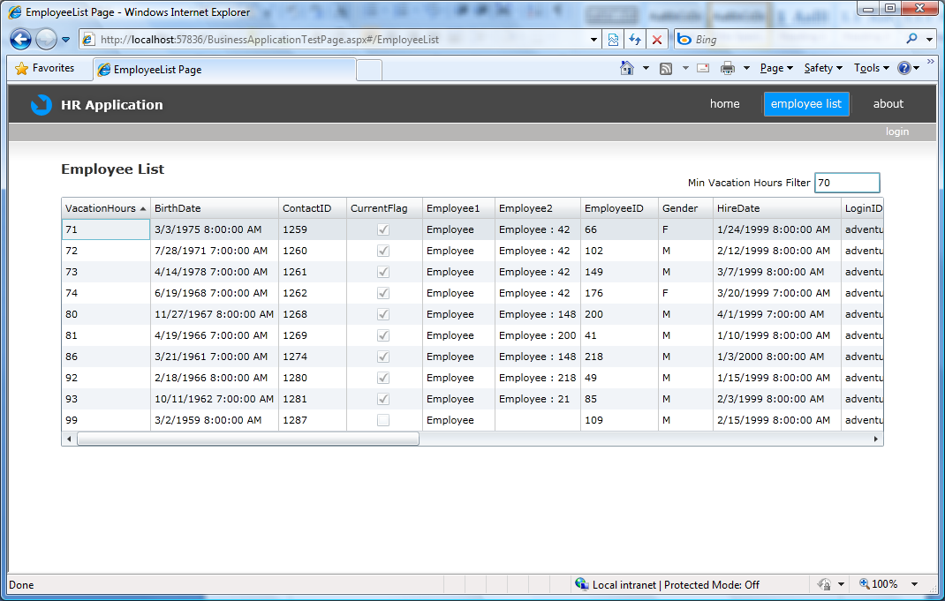

- Drag a DataPager from the toolbox on to EmployeeList.xaml. Add the DataPager just below the DataGrid.
- Set the page size to 5 and set the source by adding the following XAML to the DataPager:
<!-- XAML -->

<data:DataPager PageSize="5" Source="{Binding Data, ElementName=employeeDataSource}" Margin="0,-1,0,0"></data:DataPager>
- Run the application and click the employee list link. You will see only 5 rows of filtered data per page and pager controls below the DataGrid.
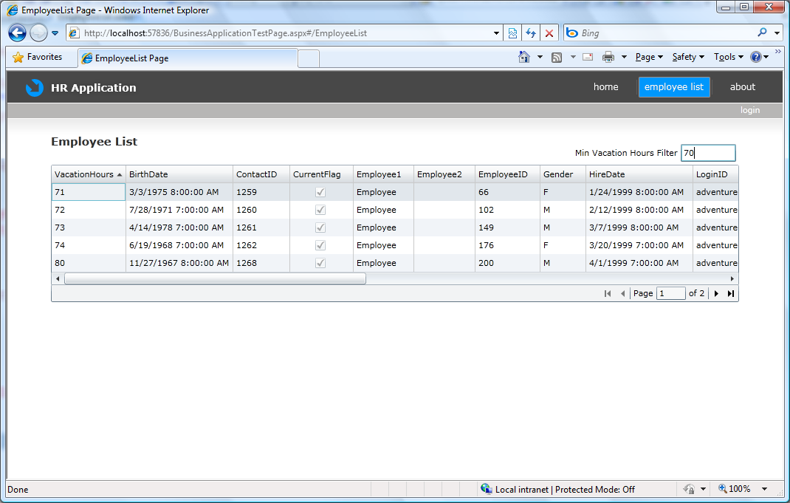

Master Detail

Adding a DataForm
We will be using the DataForm Control from the SL 3 Toolkit for the Detail View. The Silverlight Business Application Project Template carries the System.Windows.Controls.Data.DataForm.Toolkit.dll binary in the ‘Libs’ Folder, hence our Project already has access to the DataForm Control.

- In the client project, open EmployeeList.xaml.
- Add the following namespace declaration to EmployeeList.xaml.
<!-- XAML -->

xmlns:dataForm="clr-namespace:System.Windows.Controls;assembly=System.Windows.Controls.Data.DataForm.Toolkit"

- After the DataPager control, add the XAML code below. The code adds the DataForm to the EmployeeList Page and sets the DataForm attributes and specifies the columns to be displayed.

<dataForm:DataForm x:Name="dataForm1" Header="Employee Information" AutoGenerateFields="False" AutoEdit="False" AutoCommit="False" CurrentItem="{Binding SelectedItem, ElementName=dataGrid1}" Margin="0,12,0,0">
<dataForm:DataForm.EditTemplate>
<DataTemplate>
<StackPanel>
<dataForm:DataField Label="Employee ID">
<TextBox IsReadOnly="True"
Text="{Binding EmployeeID, Mode=OneWay}" />
</dataForm:DataField>
<dataForm:DataField Label="Login ID">
<TextBox Text="{Binding LoginID, Mode=TwoWay}" />
</dataForm:DataField>
<dataForm:DataField Label="Hire Date">
<TextBox Text="{Binding HireDate, Mode=TwoWay}" />
</dataForm:DataField>
<dataForm:DataField Label="Marital Status">
<TextBox Text="{Binding MaritalStatus, Mode=TwoWay}" />
</dataForm:DataField>
<dataForm:DataField Label="Gender">
<TextBox Text="{Binding Gender, Mode=TwoWay,NotifyOnValidationError=True, ValidatesOnExceptions=True }" />
</dataForm:DataField>
<dataForm:DataField Label="Vacation Hours">
<TextBox Text="{Binding VacationHours, Mode=TwoWay,NotifyOnValidationError=True, ValidatesOnExceptions=True }" />
</dataForm:DataField>
<dataForm:DataField Label="Sick Leave Hours">
<TextBox Text="{Binding SickLeaveHours, Mode=TwoWay,NotifyOnValidationError=True, ValidatesOnExceptions=True }" />
</dataForm:DataField>
<dataForm:DataField Label="Active">
<CheckBox IsChecked="{Binding CurrentFlag, Mode=TwoWay,NotifyOnValidationError=True, ValidatesOnExceptions=True }" />
</dataForm:DataField>
</StackPanel>
</DataTemplate>
</dataForm:DataForm.EditTemplate>
</dataForm:DataForm>

- Run the application and click the employee list link. The DataForm displays details of the item selected in the DataGrid.
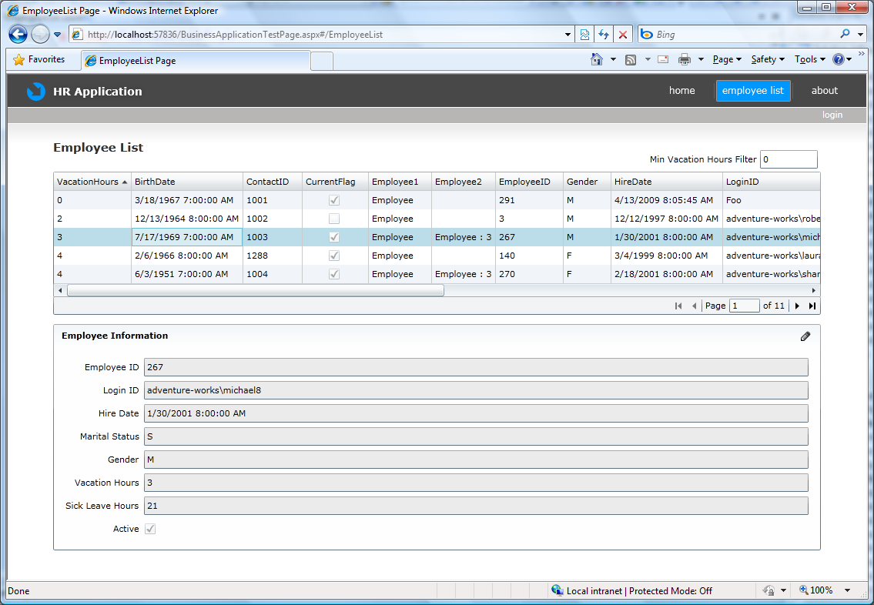

Updating the Database

Updating a record
Checking the Enable editing option in the New Domain Service Class wizard caused CUD methods to be generated automatically in the domain service layer (OrganizationService class). In order to use these methods to update the database, you will add editing buttons to the user interface of the employee list.
- In the client project, open EmployeeList.xaml.
- Add a ‘Submit’ button just after the DataForm tags by adding the following XAML code.
<!-- XAML -->

<StackPanel Orientation="Horizontal" HorizontalAlignment="Right" Margin="0,12,0,0">
<Button x:Name="submitButton" Width="75" Height="23"
Content="Submit" Margin="4,0,0,0" Click="submitButton_Click"/>

</StackPanel>
- Handle the button click event in EmployeeList.xaml.cs/vb by adding the following code:
// C#

private void submitButton_Click(object sender, RoutedEventArgs e)
{
employeeDataSource.SubmitChanges();
}

'VB
Private Sub submitButton_Click(ByVal sender As System.Object, ByVal e As System.Windows.RoutedEventArgs)
employeeDataSource.SubmitChanges()
End Sub

- Run the application and click the Employee List link. You can now modify any editable field by clicking on the pencil icon on the DataForm to put the form in edit mode. Make changes to the Employee data and click OK when done with the edits. Click the Submit button to save the data. Changes are saved to the database on the server only when you click the ‘Submit’ button.

Adding Custom Methods to a Domain Service
- In the HRApp.Web server project, open OrganizationService.cs/vb and add a custom method called ‘ApproveSabbatical’.
// C#
public void ApproveSabbatical(Employee current)
{
// Start custom workflow here
this.ObjectContext.Employees.AttachAsModified(current);
current.CurrentFlag = false;
}

'VB
Public Sub ApproveSabbatical(ByVal current As Employee)
Me.ObjectContext.Employees.AttachAsModified(current)
current.CurrentFlag = False
End Sub

- On the Build menu, select Build Solution.
- In the client project, open EmployeeList.xaml.
- Add an ‘Approve Sabbatical’ button by adding the following XAML code (in bold):

<!-- XAML -->

<StackPanel Orientation="Horizontal" HorizontalAlignment="Right" Margin="0,12,0,0">
<Button x:Name="submitButton" Width="75" Height="23" Content="Save" Margin="4,0,0,0" Click="submitButton_Click"/>
<Button x:Name="approveSabbatical" Width="115" Height="23" Content="Approve Sabbatical" Margin="4,0,0,0" Click="approveSabbatical_Click"/>
</StackPanel>
- Open EmployeeList.xaml.cs/vb.
- Handle the button click event and call the ApproveSabbatical method by adding the following code:
// C#

private void approveSabbatical_Click(object sender, RoutedEventArgs e)
{
Employee luckyEmployee = (Employee)(dataGrid1.SelectedItem);
luckyEmployee.ApproveSabbatical();
employeeDataSource.SubmitChanges();
}

'VB
Private Sub approveSabbatical_Click(ByVal sender As System.Object, ByVal e As System.Windows.RoutedEventArgs)
Dim luckyEmployee As Employee
luckyEmployee = dataGrid1.SelectedItem
luckyEmployee.ApproveSabbatical()
employeeDataSource.SubmitChanges()
End Sub

- Run the application and click the employee list link. Click the ApproveSabbatical button and note that the CurrentFlag for the selected employee clears.

Validation

Basic Validation
The DataForm control has the ability to show validation errors that come from the Data Access Layer (DAL). For example, enter a non-integer value in the Vacation Hours field in the detail view and a validation error is displayed.

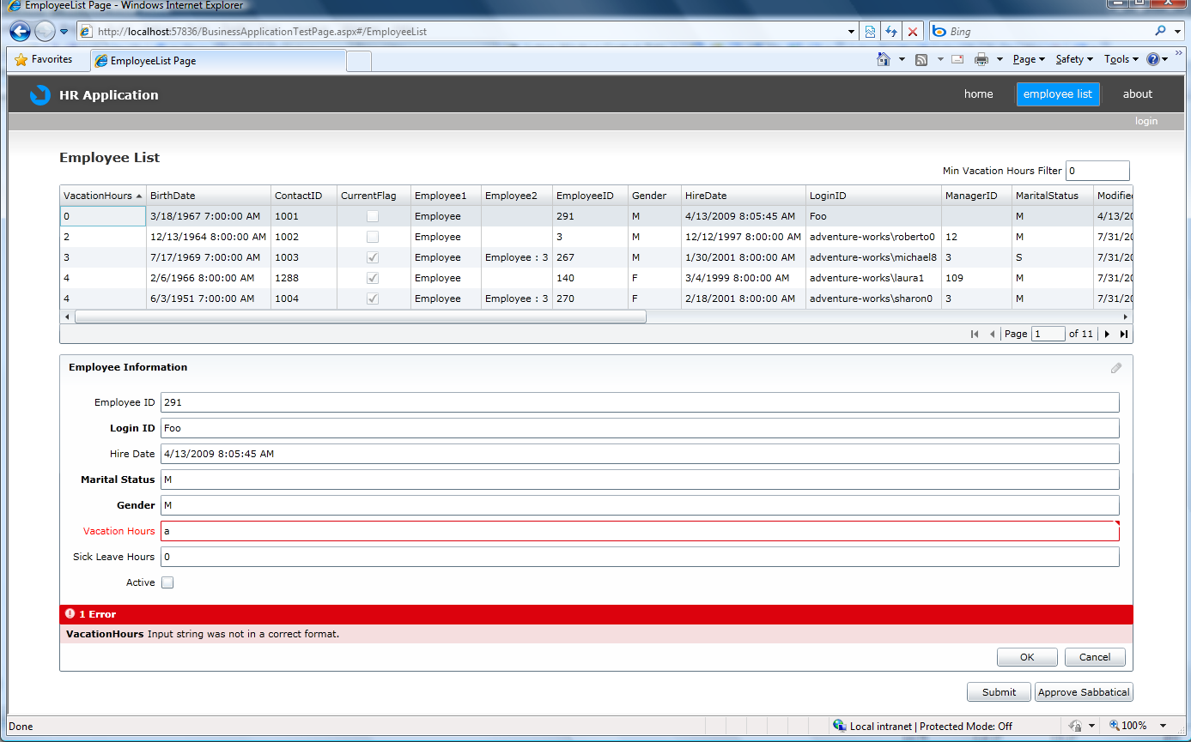
Checking the Generate associated classes for metadata option in the New Domain Service Class wizard caused a file named OrganizationService.metadata.cs/vb to be generated automatically in the HRApp.Web project. You will add validation attributes to this file that will be enforced across application tiers.
- In the HRApp.web project, open OrganizationService.metadata.cs/vb.
- Add the following attributes to Gender and Vacation Hours:
// C#

[Required]
public string Gender { get; set; }

[Range(0, 70)]
public short VacationHours { get; set; }

'VB
<Required()> _
Public Gender As String

<Range(0, 70)> _
Public VacationHours As Short
- On the Build menu, select Build Solution.
- Run the application.
- Click on the Employee List link. Select an employee and click the pencil icon in the upper right hand corner of the data form to enable editing. Enter a value into the Vacation Hours field that is not within the valid range (0-70). You will see a validation error. Also note that the Gender field is required and cannot be left empty.
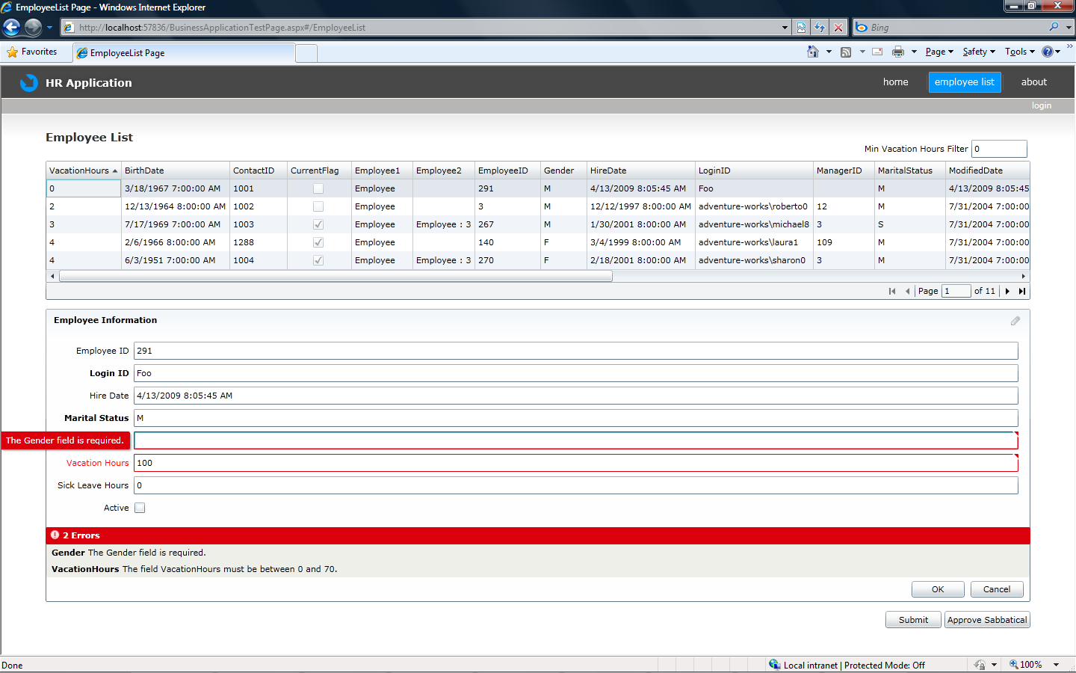

Custom Validation
- In Solution Explorer, right-click the HRApp.Web project, select Add, and then select New Item. The Add New Item dialog box is displayed.
- In the Categories pane, select Code, and in the Templates pane, select Code File. Name the new item ‘OrganizationService.shared.cs’ or ‘OrganizationService.shared.vb’ and click Add.
- Add the following block of code to the file:
// C#
using System;
using System.ComponentModel.DataAnnotations;

namespace HRApp.Web
{
public static class GenderValidator
{
public static ValidationResult IsGenderValid(string gender, ValidationContext context)
{
if (gender == "M" || gender == "m" || gender == "F" || gender == "f")
{
return ValidationResult.Success;
}
else
{
return new ValidationResult("The Gender field only has two valid values 'M'/'F'", new string[] {"Gender"});
}
}
}
}

'VB
Imports System
Imports System.ComponentModel.DataAnnotations

Public Module GenderValidator
Public Function IsGenderValid(ByVal gender As String, ByVal context As ValidationContext) As ValidationResult
If gender = "M" OrElse gender = "m" OrElse gender = "F" OrElse gender = "f" Then
Return ValidationResult.Success
Else
Return New ValidationResult("The Gender field only has two valid values 'M'/'F'", New String() {"Gender"})
End If
End Function
End Module

Note: Since the file ends with ‘.shared.cs/vb’, the same code will be available to be consumed on the client as well as the server. We will be using this to run the same validation rule at both locations. (After you rebuild the solution, look in the hidden Generated_Code folder on the client, and you will see the OrganizationService.shared.cs/vb file present there as well and being compiled as part of the server project.)
- Open OrganizationService.metadata.cs/vb.
- Add a new custom validation attribute to the gender property by adding the following code (in bold).
// C#
[CustomValidation(typeof(HRApp.Web.GenderValidator), "IsGenderValid")]
[Required]
public string Gender { get; set; }

'VB
<Required()> _
<CustomValidation(GetType(GenderValidator), "IsGenderValid")> _
Public Gender As String

- On the Build menu, select Build Solution.
- Run the application.
- Click on the Employee List link. Enter a value for the Gender field that is not ’M’ or ’F’.
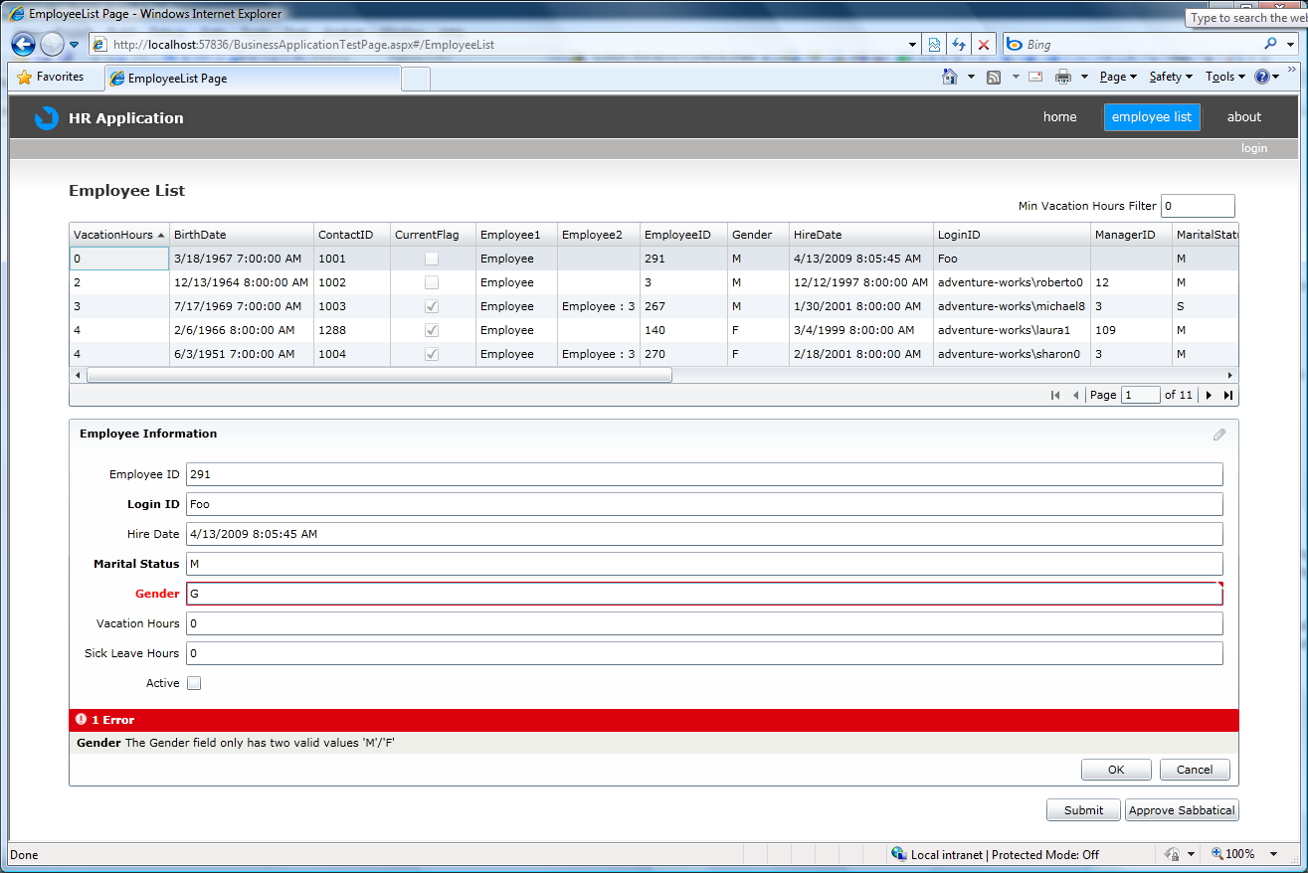

Add a new record
You will now create a user interface to allow the addition of new employee records to the database. The validation rules that you added in the previous sections will automatically be applied in the new user interface.
- In Solution Explorer, right-click the HRApp project, select Add, and then select New Item. The Add New Item dialog box is displayed.
- In the Categories pane, select Silverlight, and in the Templates pane, select Silverlight Child Window. Name the new item ‘EmployeeRegistrationWindow.xaml’ and click Add.
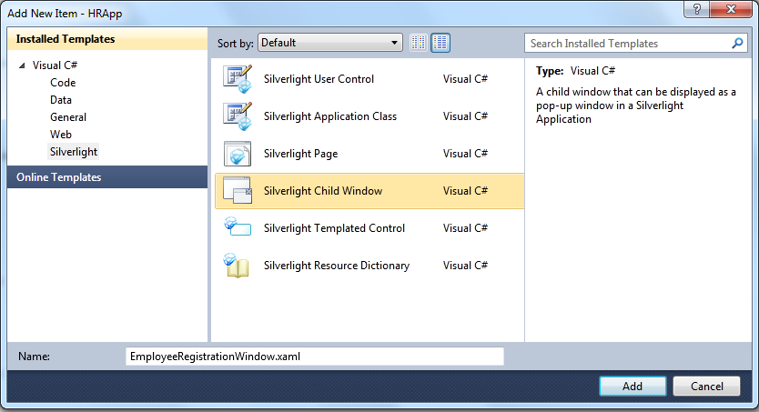

- Open EmployeeRegistrationWindow.xaml.cs/vb and add the following using/Imports statement:
// C#
using HRApp.Web;

'VB
Imports System.Windows.Controls
Imports System.Windows

- Add the following property in the code:
// C#
public Employee NewEmployee { get; set; }

'VB
Public Property NewEmployee As Employee

- Open EmployeeRegistrationWindow.xaml.

- Hide the ChildWindow Close button by adding the XAML in bold below.
<controls:ChildWindow x:Class="HRApp.EmployeeRegistrationWindow"
…
Width="400" Height="300"
Title="EmployeeRegistrationWindow" HasCloseButton="False">

- As we did for the Details view, here too we will be using the DataForm Control from the SL 3 Toolkit. The Silverlight Business Application Project Template carries the System.Windows.Controls.Data.DataForm.Toolkit binary in the ‘Libs’ Folder, hence our Project already has access to the DataForm Control.

Add the following namespace declaration to EmployeeRegistrationWindow.xaml:
<!-- XAML -->

xmlns:dataForm="clr-namespace:System.Windows.Controls;assembly=System.Windows.Controls.Data.DataForm.Toolkit"

- Add the DataForm from to the EmployeeRegistrationWindow.xaml just above the ‘Cancel’ button using the XAML Code below.
<dataForm:DataForm x:Name="addEmployeeDataForm" AutoGenerateFields="False" AutoCommit="True" AutoEdit="True" CommandButtonsVisibility="None">
<dataForm:DataForm.EditTemplate>
<DataTemplate>
<StackPanel>
<dataForm:DataField Label="Login ID">
<TextBox Text="{Binding LoginID, Mode=TwoWay}" />
</dataForm:DataField>
<dataForm:DataField Label="National ID">
<TextBox Text="{Binding NationalIDNumber, Mode=TwoWay}" />
</dataForm:DataField>
<dataForm:DataField Label="Title">
<TextBox Text="{Binding Title, Mode=TwoWay}" />
</dataForm:DataField>
<dataForm:DataField Label="Marital Status">
<TextBox Text="{Binding MaritalStatus, Mode=TwoWay}" />
</dataForm:DataField>
<dataForm:DataField Label="Gender">
<TextBox Text="{Binding Gender, Mode=TwoWay,NotifyOnValidationError=True, ValidatesOnExceptions=True }" />
</dataForm:DataField>
<dataForm:DataField Label="Salaried">
<CheckBox IsChecked="{Binding SalariedFlag, Mode=TwoWay,NotifyOnValidationError=True, ValidatesOnExceptions=True }" />
</dataForm:DataField>
<dataForm:DataField Label="Active">
<CheckBox IsChecked="{Binding CurrentFlag, Mode=TwoWay,NotifyOnValidationError=True, ValidatesOnExceptions=True }" />
</dataForm:DataField>
</StackPanel>
</DataTemplate>
</dataForm:DataForm.EditTemplate>
</dataForm:DataForm>

- Open EmployeeRegistrationWindow.xaml.cs/vb and add the following code (in bold):
// C#

public partial class EmployeeRegistrationWindow : ChildWindow
{
public Employee NewEmployee { get; set; }

public EmployeeRegistrationWindow()
{
InitializeComponent();
NewEmployee = new Employee();
addEmployeeDataForm.CurrentItem = NewEmployee;
addEmployeeDataForm.BeginEdit();
}

private void OKButton_Click(object sender, RoutedEventArgs e)
{
addEmployeeDataForm.CommitEdit();
this.DialogResult = true;
}

private void CancelButton_Click(object sender, RoutedEventArgs e)
{
NewEmployee = null;
addEmployeeDataForm.CancelEdit();
this.DialogResult = false;
}
}

'VB
Partial Public Class EmployeeRegistrationWindow
Inherits ChildWindow

Public Sub New()
InitializeComponent()
NewEmployee = New Employee
addEmployeeDataForm.CurrentItem = NewEmployee
addEmployeeDataForm.BeginEdit()
End Sub

Public Property NewEmployee As Employee

Private Sub OKButton_Click(ByVal sender As Object, ByVal e As RoutedEventArgs) Handles OKButton.Click
Me.addEmployeeDataForm.CommitEdit()
Me.DialogResult = True
End Sub

Private Sub CancelButton_Click(ByVal sender As Object, ByVal e As RoutedEventArgs) Handles CancelButton.Click
NewEmployee = Nothing
addEmployeeDataForm.CancelEdit()
Me.DialogResult = False
End Sub

End Class

- Open EmployeeList.xaml.
- Add a button called ‘addNewEmployee’ between the DataPager and the DataForm by adding the following XAML code.
<!-- XAML -->

<StackPanel Orientation="Horizontal" HorizontalAlignment="Right" Margin="0,12,0,0">
<Button x:Name="addNewEmployee" Width="90" Height="23" Content="Add Employee" Margin="4,0,0,0" Click="addNewEmployee_Click"/>
</StackPanel>
- Open EmployeeList.xaml.cs/vb.
- Handle the button click event to show the EmployeeRegistrationWindow by adding the following code:
// C#

private void addNewEmployee_Click(object sender, RoutedEventArgs e)
{
EmployeeRegistrationWindow addEmp = new EmployeeRegistrationWindow();
addEmp.Closed += new EventHandler(addEmp_Closed);
addEmp.Show();
}

'VB
Private Sub addNewEmployee_Click(ByVal sender As System.Object, ByVal e As System.Windows.RoutedEventArgs)
Dim addEmp As New EmployeeRegistrationWindow()
AddHandler addEmp.Closed, AddressOf addEmp_Closed
addEmp.Show()
End Sub

- Add the following method to handle the closed event for the EmployeeRegistrationWindow:
// C#

void addEmp_Closed(object sender, EventArgs e)
{
EmployeeRegistrationWindow emp = (EmployeeRegistrationWindow)sender;
if (emp.NewEmployee != null)
{
OrganizationContext _OrganizationContext = (OrganizationContext)(employeeDataSource.DomainContext);
_OrganizationContext.Employees.Add(emp.NewEmployee);
employeeDataSource.SubmitChanges();
}
}

'VB
Private Sub addEmp_Closed(ByVal sender As Object, ByVal e As System.EventArgs)
Dim emp As EmployeeRegistrationWindow = sender
If Not emp.NewEmployee Is Nothing Then
Dim _OrganizationContext As OrganizationContext = employeeDataSource.DomainContext
_OrganizationContext.Employees.Add(emp.NewEmployee)
employeeDataSource.SubmitChanges()
End If
End Sub

- In the HRApp.web project, open OrganizationService.cs/vb.
- Add the following code (in bold) to the InsertEmployee method:
// C#

public void InsertEmployee(Employee employee)
{
// Modify the employee data to meet the database constraints.
employee.HireDate = DateTime.Now;
employee.ModifiedDate = DateTime.Now;
employee.VacationHours = 0;
employee.SickLeaveHours = 0;
employee.rowguid = Guid.NewGuid();
employee.ContactID = 1001;
employee.BirthDate = new DateTime(1967, 3, 18);

if ((employee.EntityState != EntityState.Detached))
{
this.ObjectContext.ObjectStateManager.ChangeObjectState(employee, EntityState.Added);
}
else
{
this.ObjectContext.Employees.AddObject(employee);
}
}

'VB
Public Sub InsertEmployee(ByVal employee As Employee)
'Modify the employee data to meet the database constraints.
employee.HireDate = DateTime.Now
employee.ModifiedDate = DateTime.Now
employee.VacationHours = 0
employee.SickLeaveHours = 0
employee.rowguid = Guid.NewGuid()
employee.ContactID = 1001
employee.BirthDate = New DateTime(1967, 3, 18)

If ((employee.EntityState = EntityState.Detached) = False) Then
Me.ObjectContext.ObjectStateManager.ChangeObjectState(employee, EntityState.Added)
Else
Me.ObjectContext.Employees.AddObject(employee)
End If

End Sub

- Run the application.
- Click the employee list link.
You can now add new employees to the database by clicking the ‘Add Employee’ button. To ensure that the new employee appears in the list, mark the employee as Salaried. Earlier you modified the application to only load salaried employees.
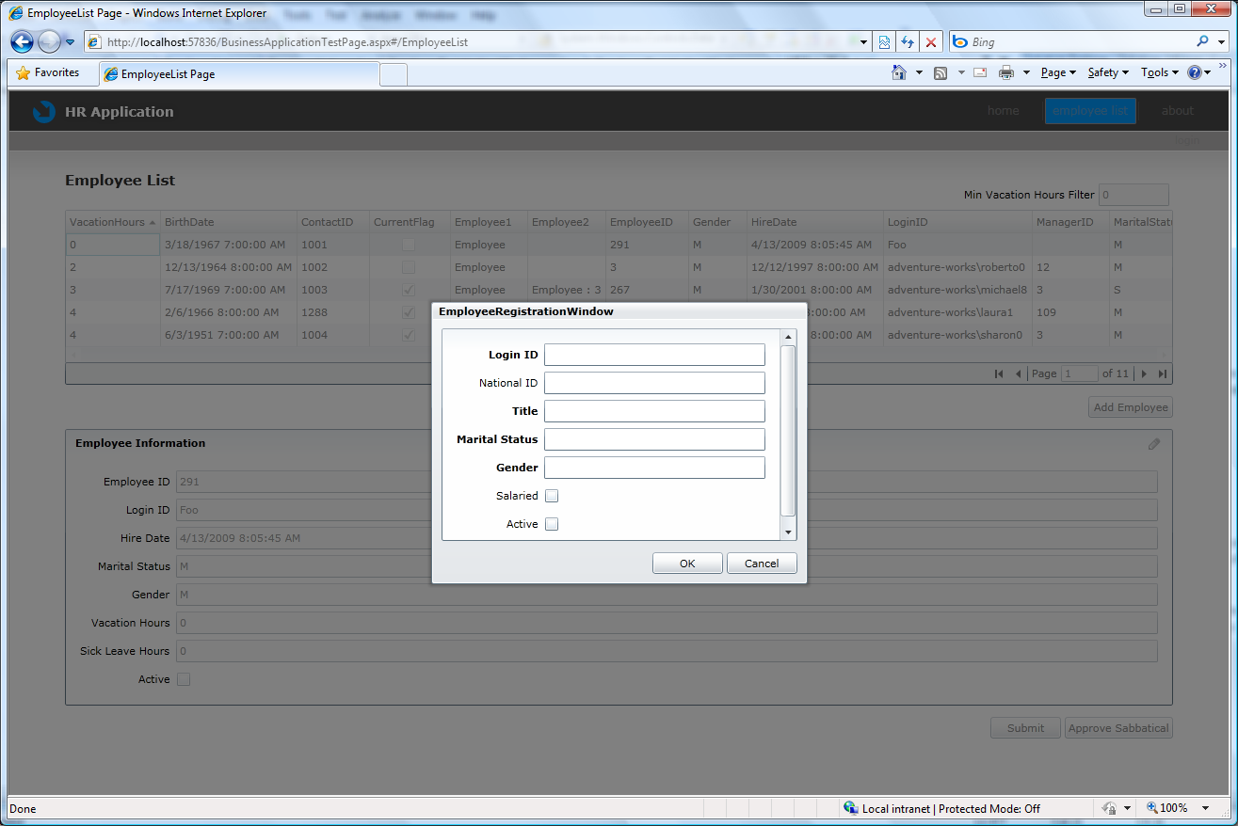

Authentication

Authentication
- Open OrganizationService.cs/vb
- Add the RequiresAuthentication attribute on the ApproveSabbatical method by adding the following code (in bold).
This ensures that only authenticated users can now call the ApproveSabbatical method on the server. If an anonymous user clicks on the ApproveSabbatical button, the CurrentFlag for the selected employee will not be cleared.
// C#
[RequiresAuthentication()]
public void ApproveSabbatical(Employee current)
{
// Start custom workflow here
this.ObjectContext.Employees.AttachAsModified(current);
current.CurrentFlag = false;
}

'VB
<RequiresAuthentication()> _
Public Sub ApproveSabbatical(ByVal current As Employee)
Me.ObjectContext.Employees.AttachAsModified(current)
current.CurrentFlag = False
End Sub

- In the client project, open EmployeeList.xaml.cs/vb.
- Add the following using/Imports statements:
// C#
using System.ServiceModel.DomainServices.Client.ApplicationServices;
using HRApp.LoginUI;

'VB
Imports System.ServiceModel.DomainServices.Client.ApplicationServices

- Modify the approveSabbatical_Click method with the following code:
This will allow anonymous users to get authenticated and then approve a sabbatical.
If the users do not have an existing user account they can create one using the Registration Dialog.

//C#
private void approveSabbatical_Click(object sender, RoutedEventArgs e)
{
if (WebContext.Current.User.IsAuthenticated)
{
Employee luckyEmployee = (Employee)(dataGrid1.SelectedItem);
luckyEmployee.ApproveSabbatical();
employeeDataSource.SubmitChanges();
}
else
{
WebContext.Current.Authentication.LoggedIn += Authentication_LoggedIn;
new LoginRegistrationWindow().Show();
}
}

private void Authentication_LoggedIn(object sender, AuthenticationEventArgs e)
{
Employee luckyEmployee = (Employee)(dataGrid1.SelectedItem);
luckyEmployee.ApproveSabbatical();
employeeDataSource.SubmitChanges();

WebContext.Current.Authentication.LoggedIn -= Authentication_LoggedIn;
}

'VB
Private Sub approveSabbatical_Click(ByVal sender As Object, ByVal e As System.Windows.RoutedEventArgs)
If WebContext.Current.User IsNot Nothing AndAlso WebContext.Current.User.IsAuthenticated Then
Dim luckyEmployee As Employee = dataGrid1.SelectedItem
luckyEmployee.ApproveSabbatical()
employeeDataSource.SubmitChanges()
Else
AddHandler WebContext.Current.Authentication.LoggedIn, AddressOf Current_LoginCompleted
Dim newWindow As New LoginRegistrationWindow
newWindow.Show()
End If
End Sub

Private Sub Current_LoginCompleted(ByVal sender As Object, ByVal e As AuthenticationEventArgs)
Dim luckyEmployee As Employee = dataGrid1.SelectedItem
luckyEmployee.ApproveSabbatical()
employeeDataSource.SubmitChanges()
RemoveHandler WebContext.Current.Authentication.LoggedIn, AddressOf Current_LoginCompleted
End Sub
- Run the application and click the employee list link.
- Select an employee record and click the ‘Approve Sabbatical’ button. You are redirected to the login page.
- Enter your credentials to login, or click register.
After login is completed, you are redirected to the Employee List page and the employee’s sabbatical is approved.

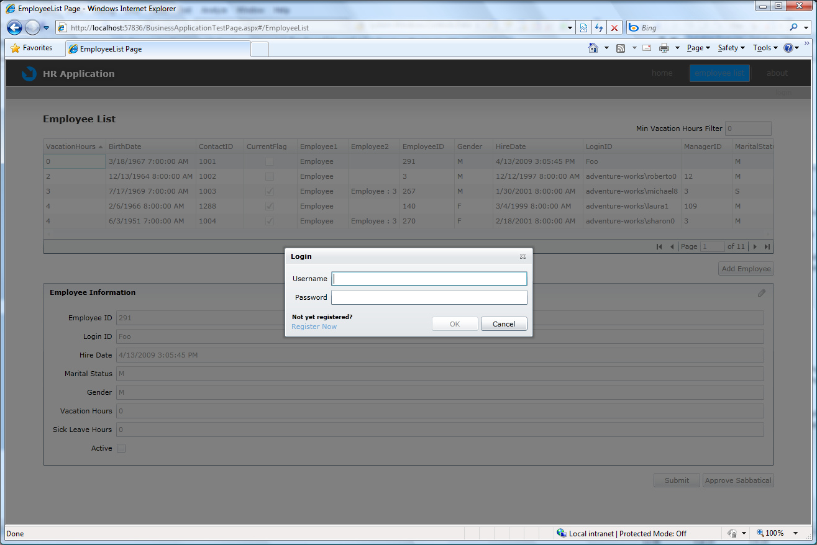

Completed Projects
The completed projects for both VB and C# can be found at:-
http://go.microsoft.com/fwlink/?LinkId=145481

